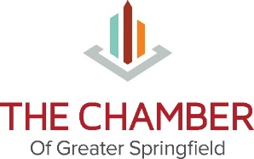
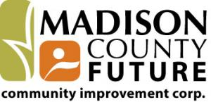
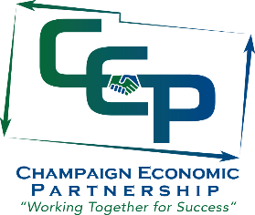
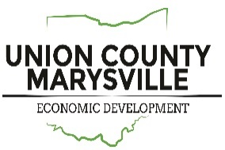

Champaign, Clark, Logan,
Madison and Union Counties

June 5, 2017

Dear Champaign County Employers,

In order to serve current businesses and attract new businesses to our region we are often asked to provide wage and benefits information. Local economic development groups and OhioMeansJobs offices from Champaign, Clark, Logan, Madison and Union counties are asking for your help. The link below will take you to a survey that gathers information about your organization’s benefits. Wage information will be obtained from EMSI through a partnership with Dayton Development Coalition. Both the wage and benefits statistics will be included in the final report.

Dr. Wendy Gradwohl, a local consultant and professor, will be performing the data analysis and report development. If, after you’ve submitted your survey responses, any clarification is needed, you may be contacted by Wendy. Data will be reported in aggregate only, so your organization's information will be completely confidential.

The survey can be accessed by the following link:
www.surveymonkey.com/r/2017_Regional_Wage_and_Benefit_Study

A pdf version of the survey is attached to help you prepare responses prior to accessing the online survey.

If you are unable to complete the online survey in one sitting, you may exit the survey and complete the remaining questions later. Your answers will be saved automatically as long as you re-enter the survey using the same URL above, and you must continue filling out the survey on the same computer and not delete your cookies.

We understand that providing this information will take valuable time, but this survey is critical to help move forward our region’s business growth and expansion. As an inducement to complete the online survey by June 24, 2017, your organization will receive a copy of the final report in September 2017. Organizations that do not complete the survey but would like the final report may obtain a copy from their local economic development website in January 2018.

If you have any questions, please contact Marcia Bailey @ (937) 653-7200 or via e-mail at marcia.@cepohio.com. If you have specific questions about survey items, please contact Wendy Gradwohl at 937.475.6408 or via email at wendygradwohl@gmail.com.

Thank you for your support of our community.

Marcia Bailey
Economic Development Director
Champaign Economic Partnership

